Create A Protecting Folder/Directory

In this folder, all files will be encrypted and another one cannot access this encrypted files. To do this (creating a protecting folder) there is a library: ecryptfs-utils (encrypt file system utilitys).

To download this library; sudo apt install ecryptfs-utils

Let’s create a folder as ‘secrets’;
sudo mkdir /secrets

Then we gain access to entire file system (files) of the secrets folder with encryption by using itself as device; (for detailed information, examine the manual page of mount)
Note: The argument following the -t is used to indicate the file system type and here the fs type is Ecryptfs!
sudo mount -t ecryptfs /Secrets /Secrets → The first ‘Secrets’ is device and the other is directory (folder)!
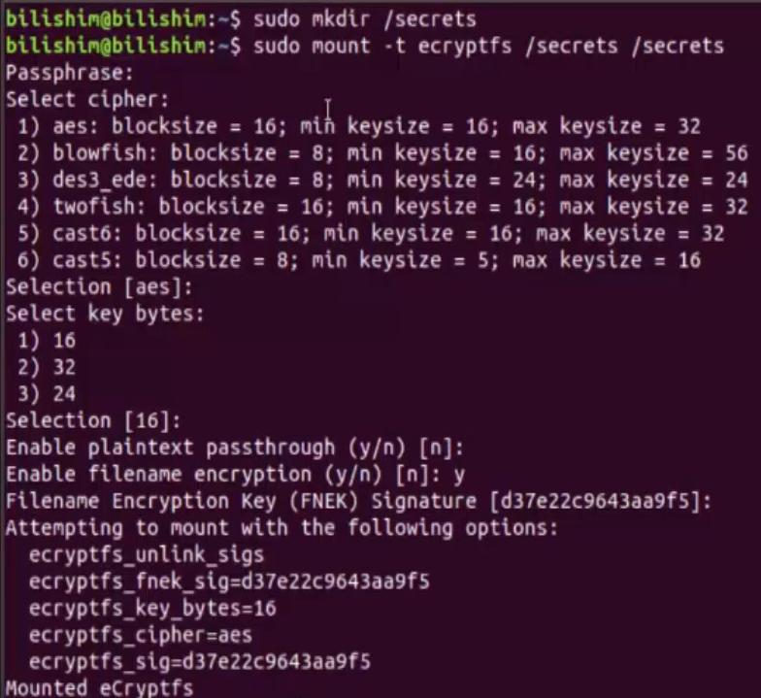

And when we type the ls command, surely there is nothing for now!
Ok then let’s create a file named ‘top secret’:

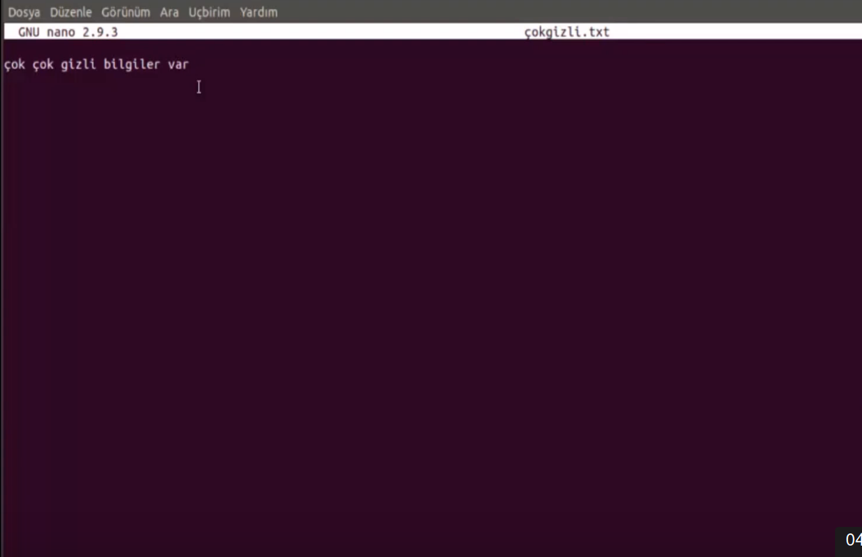
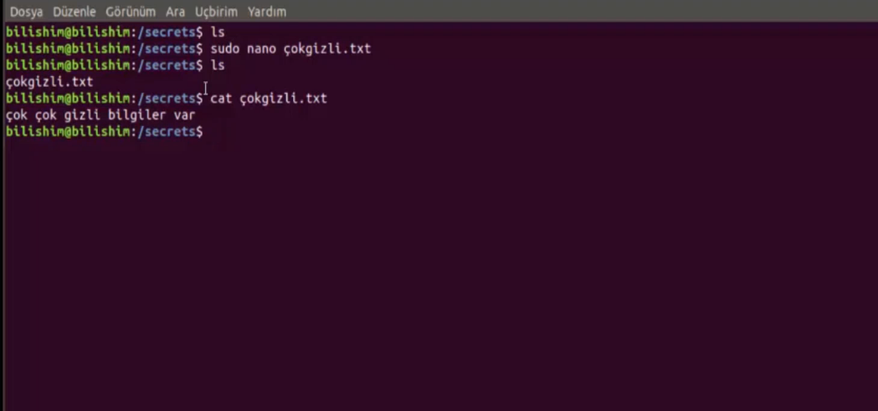
Then as you see below, we can reach the txt file:
Now let’s unmount the Secrets folder to see whether the folder is encrypted:
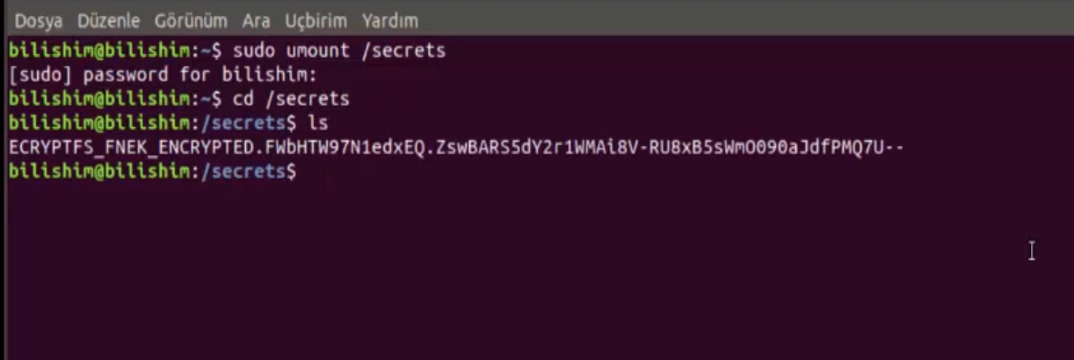

Note that even the file name was encrypted! Then if we try to run the file, we’ll encounter such a view:
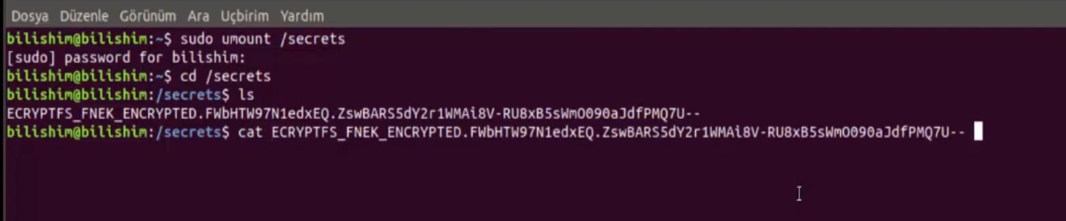
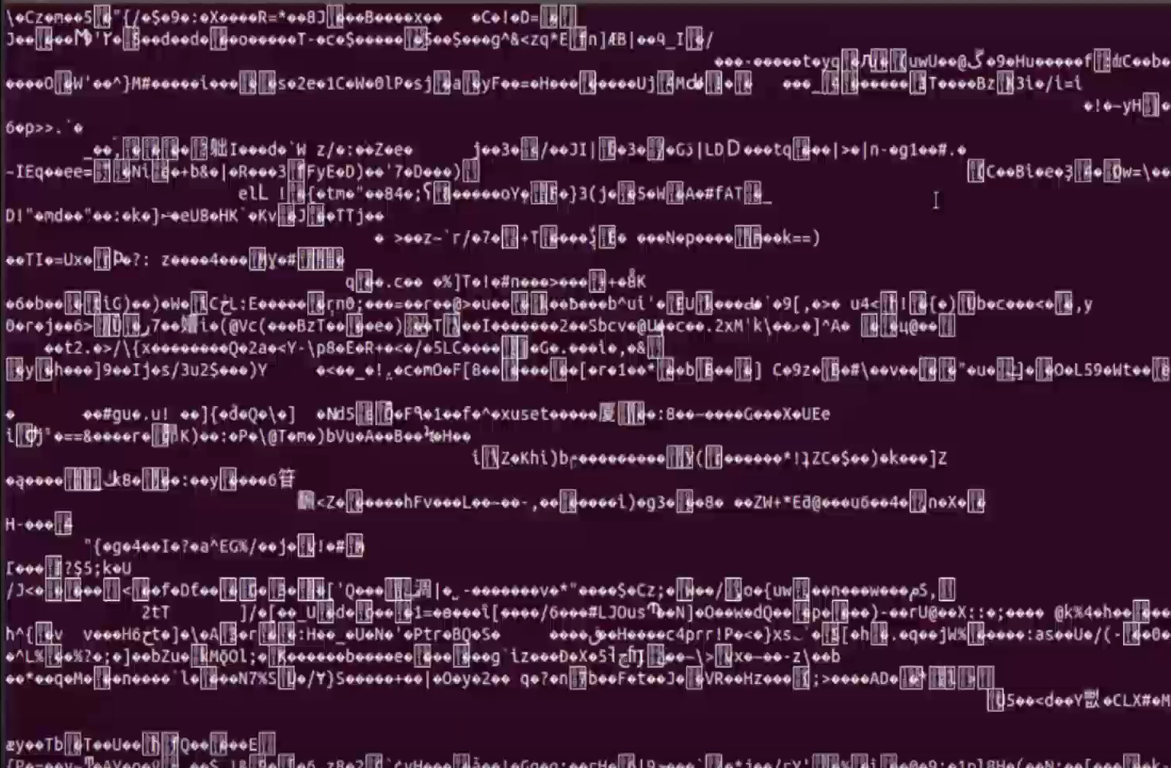

As you can see, first we mounted the folder ‘Secrets’ (we showed the disk to the memory) and then when we unmounted the disk (when we corrupt our connect of disk that we mounted as encrypted); we saw that we cannot reach their files (we cannot read because they are encrypted)!

Okay what we can do? We can mount this /Secrets disk with the ecryptfs again. But this time,
let’s add the parameters that is asked by the system (passphrase etc…) into the command to so as not to waste time with them again as follows;

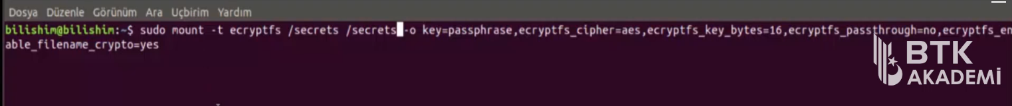

Then when we tried to enter to the /Secrets, this time it’ll be success! Because this time the folder decrypted with the unmounting process.

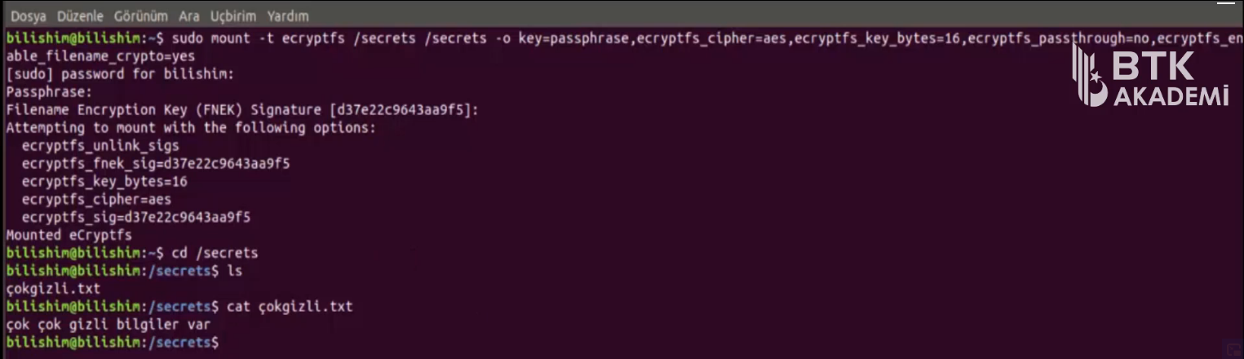
As a result; if we encrypt a folder then all what we need to do is to mount the folder by using the ecryptfs-utils library and if we decrypt that folder, then to unmount folder by using the ecryptfs-utils again!

